**DATABASE PROJECT**

**UNIVERSITIES**

BY NAFORNITA DANIELA ANDREA

CSIE YEAR 2

The target of the project is to design a database in a database management system(named SQL Oracle Developer) specially for usage of managing data about different universities in Bucharest. This project contains different tables who are managed specially to show what are the relations between different institutions, employees, and students.With this database, we will find out which universities are sponsorised by which sponsors(like Vodafone, Orange, Accenture), and more details about different students, and their teachers.

In order to be all clear, I have created 5 main tables who are about: sponsors, teachers, universities,gradebook, and students. In my opinion, those are the main options who we can relate to when we talk about managing a database for universities in general. Because most of them are in relations „many-to-many”, I have created some intermediary tabels who are in relation with minimum 2 main tables, and I named them as a combination of two in order to be easy to recognize them.

Note: The schema is the same as in semester 1.

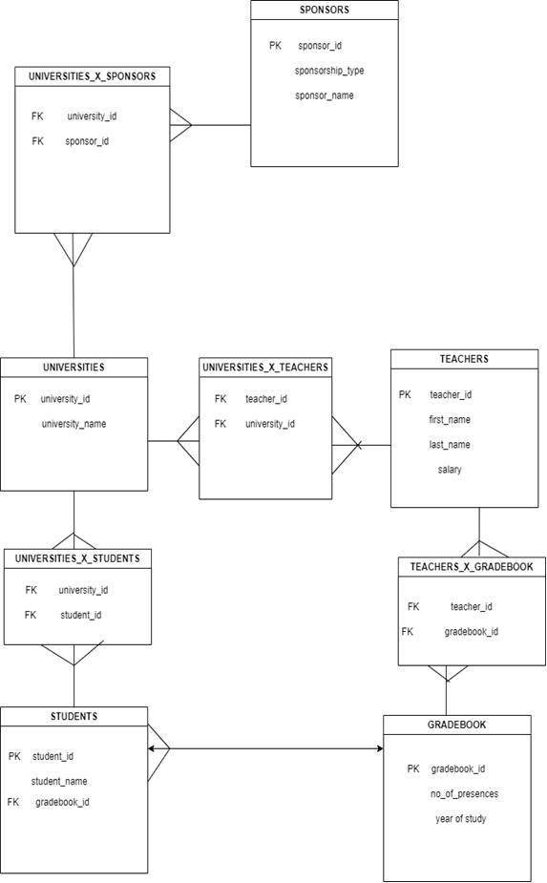

**From the table created below, we can conclude that: because most of the tables were in relation „many to many”, and it is forbidden to make a table like that and to make foreign keys and primary keys, I have created some „intermediary” tables who can give to the tables the relation „one to many” who is allowed to be made.**

To be more explicit, those are the main topics that we are going to talk about:

1. Interaction with the Oracle server through SQL commands (LDD and LMD): the use of execute immediate, particularities regarding the use of the select command as well as row and group level functions.
2. Alternate and repetitive structures.
3. Data collections (index by table, nested table, varray)
4. Exception handling. (minimum 3 implicit, 2 explicit)
5. Cursor handling: default and explicit (with and without parameters)
6. Functions, procedures, their inclusion in packages. (minimum 3 functions, 3 procedures and a package that includes other functions and procedures)
7. Statement-level and row-level triggers (minimum 2 of each)

**1. Interaction with the Oracle server through SQL commands (LDD and LMD): the use of execute immediate.**

*1.1.1 LDD (Data Definition Language) commands:* ***ALTER*** *- Alter a table using* ***EXECUTE IMMEDIATE****:*

DECLARE

v_table_name VARCHAR2(30) := 'teachers';

BEGIN

EXECUTE IMMEDIATE 'ALTER TABLE ' || v_table_name || ' ADD (experiences NUMBER)';

DBMS_OUTPUT.PUT_LINE('Table ' || v_table_name || ' altered.');

END;

/

DECLARE

v_table_name VARCHAR2(30) := 'teachers';

BEGIN

EXECUTE IMMEDIATE 'ALTER TABLE ' || v_table_name || ' ADD (grade NUMBER)';

DBMS_OUTPUT.PUT_LINE('Table ' || v_table_name || ' altered.');

END;

/

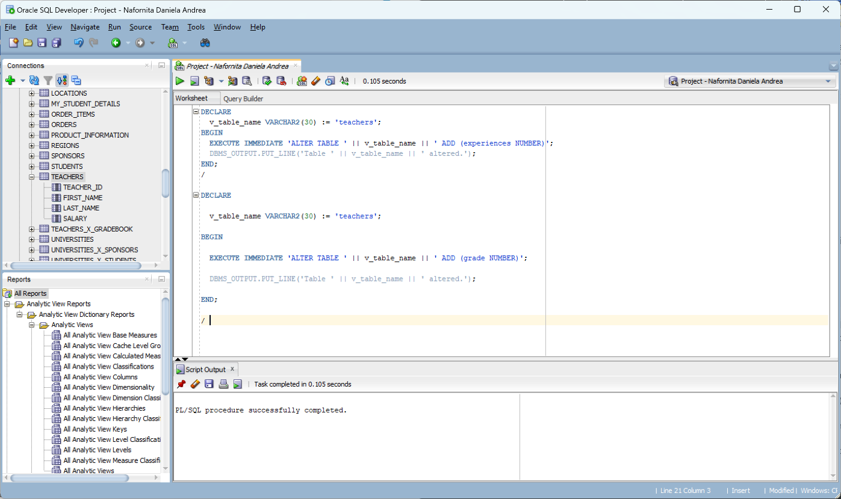

*1.1.2 LDD (Data Definition Language) commands:* ***CREATE*** *- Create a table using* ***EXECUTE IMMEDIATE****:*

DECLARE

v_table_name VARCHAR2(30) := 'person';

BEGIN

EXECUTE IMMEDIATE 'CREATE TABLE ' || v_table_name || ' (id NUMBER, name VARCHAR2(30))';

DBMS_OUTPUT.PUT_LINE('Table ' || v_table_name || ' created.');

END;

/

DECLARE

v_table_name VARCHAR2(30) := 'guests';

BEGIN

EXECUTE IMMEDIATE 'CREATE TABLE ' || v_table_name || ' (id NUMBER, name VARCHAR2(30))';

DBMS_OUTPUT.PUT_LINE('Table ' || v_table_name || ' created.');

END;

/

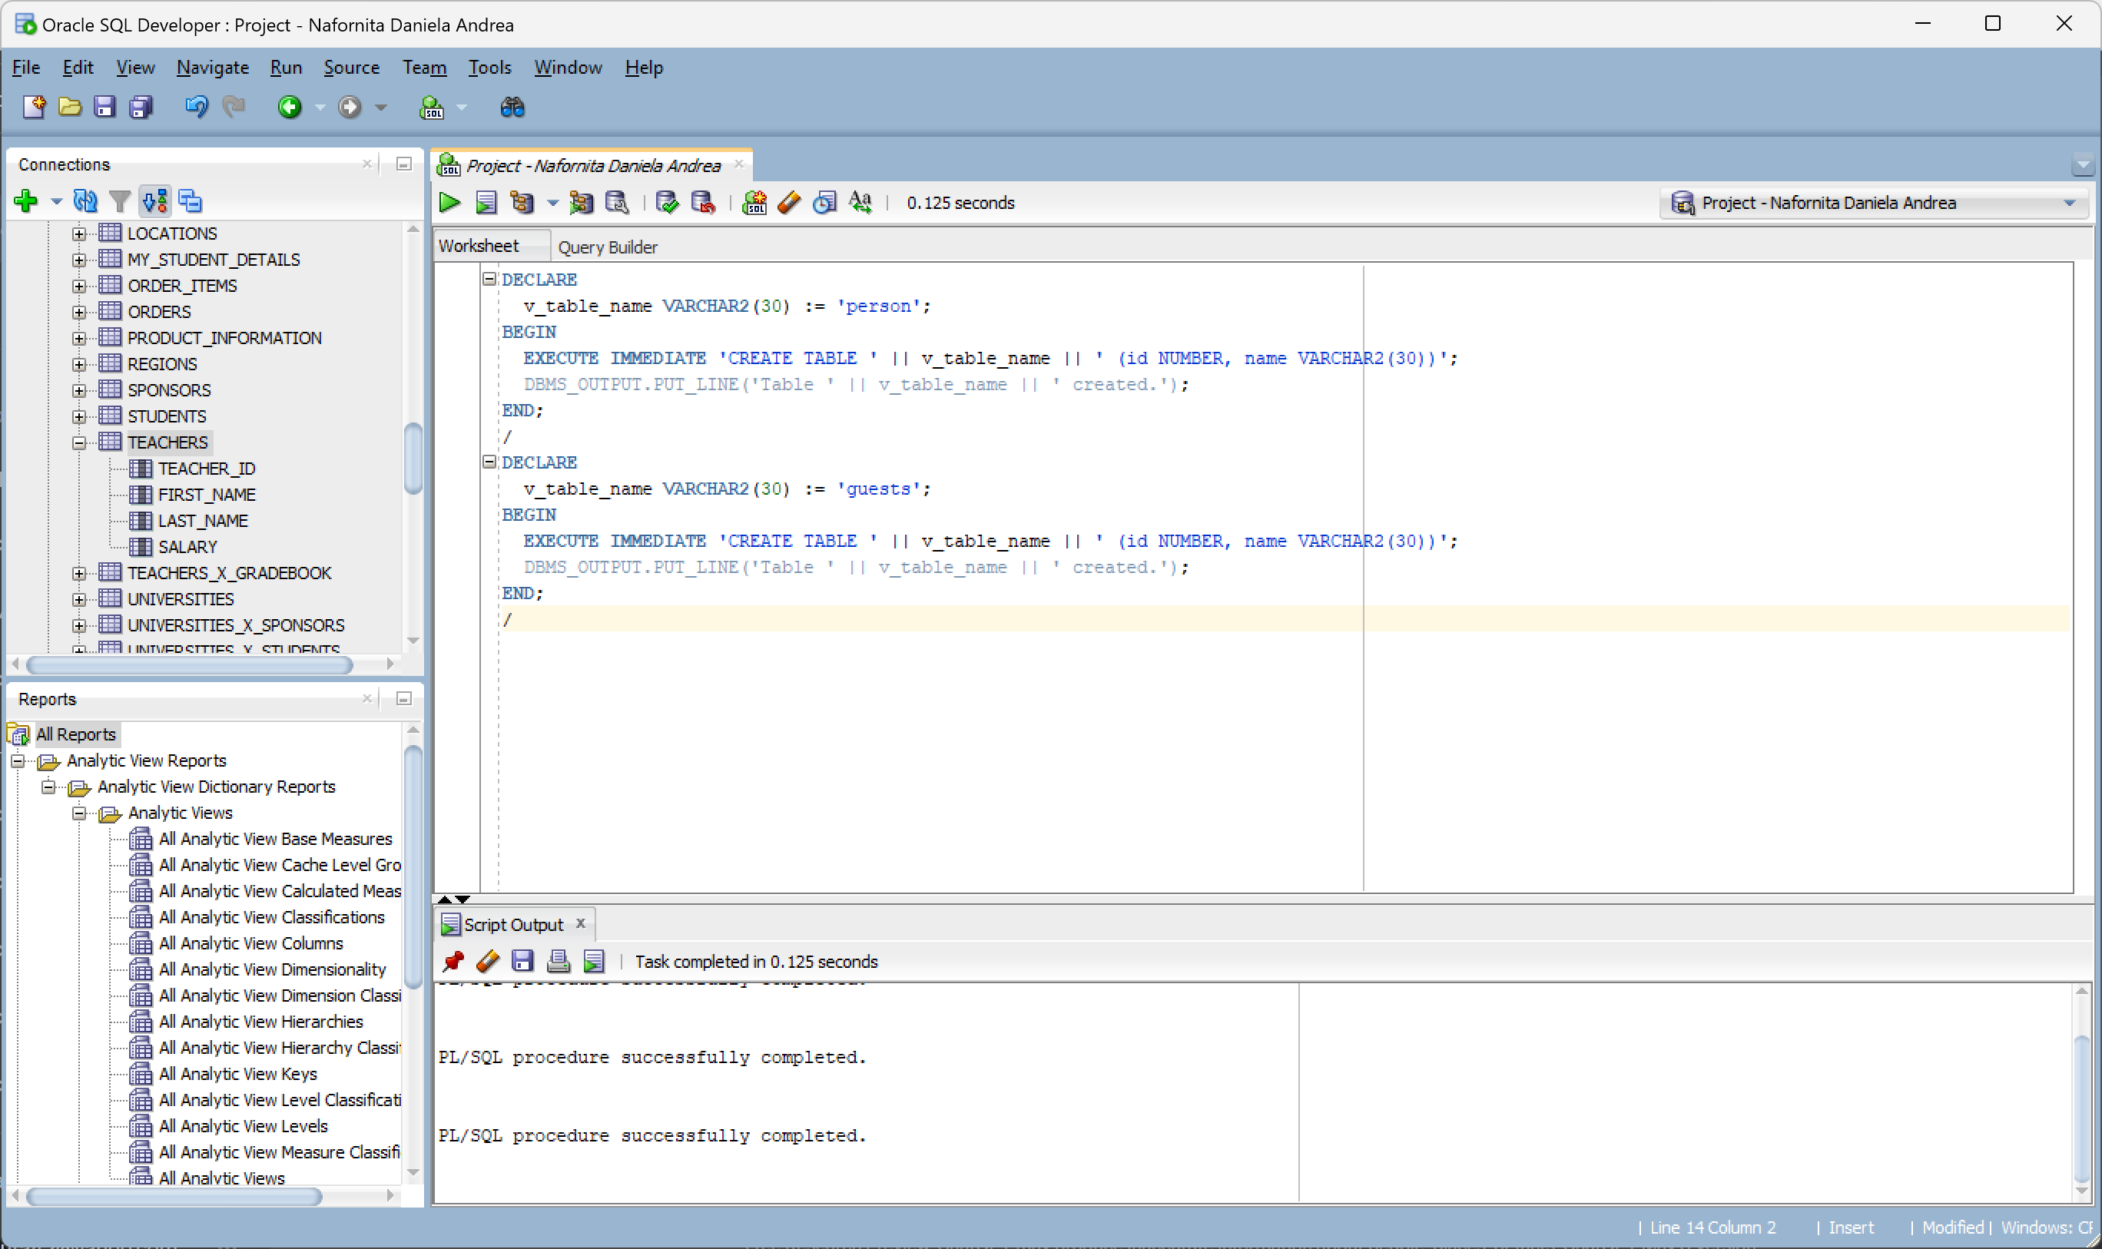

*1.1.3 LDD (Data Definition Language) commands:* ***DROP*** *- Drop a table using* ***EXECUTE IMMEDIATE****:*

DECLARE

v_table_name VARCHAR2(30) := 'person';

BEGIN

EXECUTE IMMEDIATE 'DROP TABLE ' || v_table_name;

DBMS_OUTPUT.PUT_LINE('Table ' || v_table_name || ' dropped.');

END;

/

DECLARE

v_table_name VARCHAR2(30) := 'guests';

BEGIN

EXECUTE IMMEDIATE 'DROP TABLE ' || v_table_name;

DBMS_OUTPUT.PUT_LINE('Table ' || v_table_name || ' dropped.');

END;

/

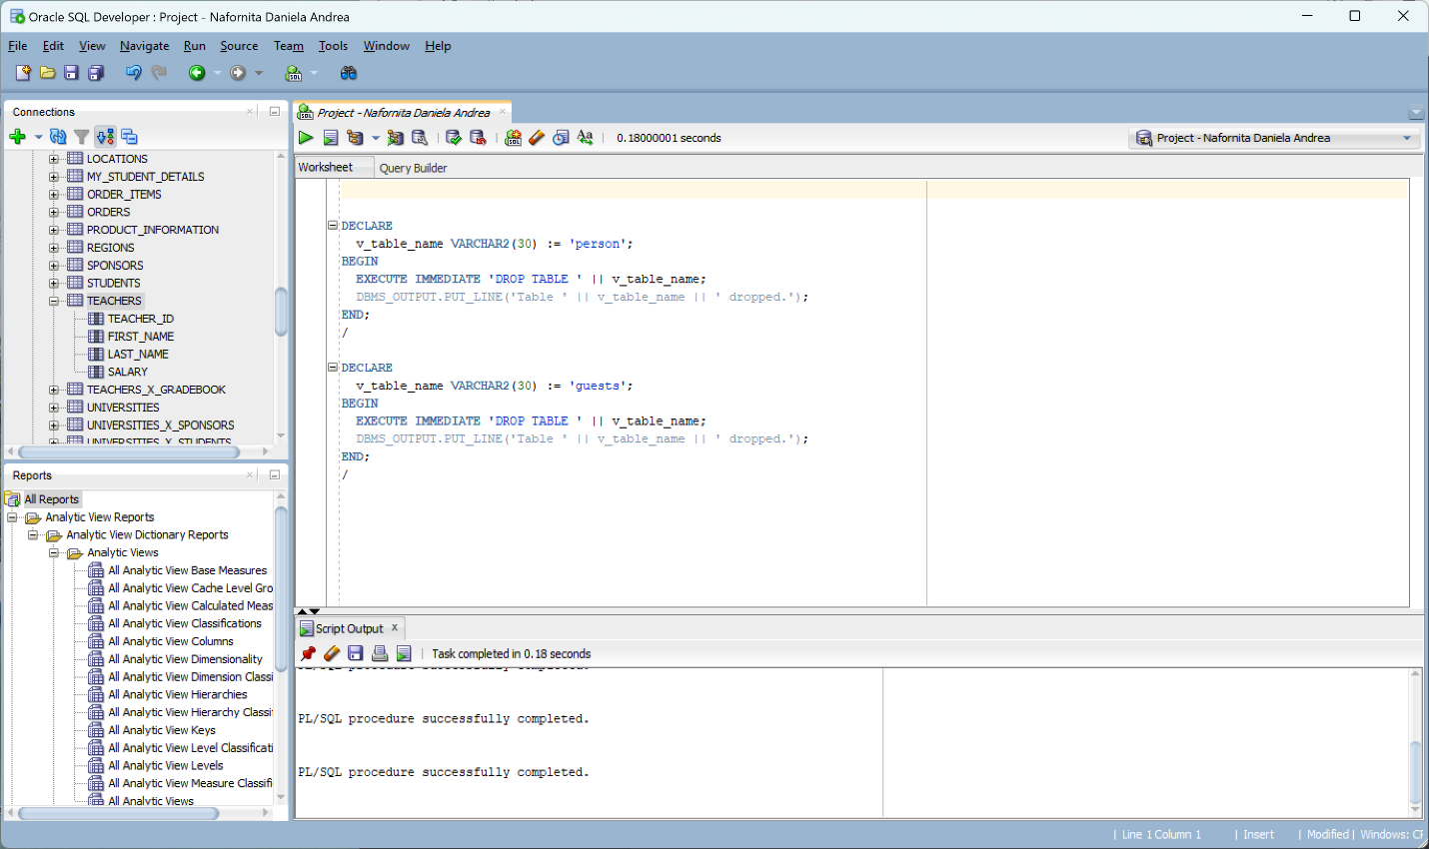

*1.2.1 LMD (Data Manipulation Language) commands: SELECT statement using EXECUTE command:*

DECLARE

v_sql_stmt VARCHAR2(1000);

teacher_id NUMBER(6) := 100;

last_name VARCHAR2(15);

first_name VARCHAR2(15);

BEGIN

v_sql_stmt := 'SELECT teacher_id, last_name, first_name FROM teachers WHERE teacher_id = :id';

EXECUTE IMMEDIATE v_sql_stmt INTO teacher_id, last_name, first_name USING teacher_id;

DBMS_OUTPUT.PUT_LINE('Teacher ID is ' || teacher_id || ', Last Name is ' || last_name || ', First Name is ' || first_name);

EXCEPTION

WHEN NO_DATA_FOUND THEN

DBMS_OUTPUT.PUT_LINE('No data found.');

END;

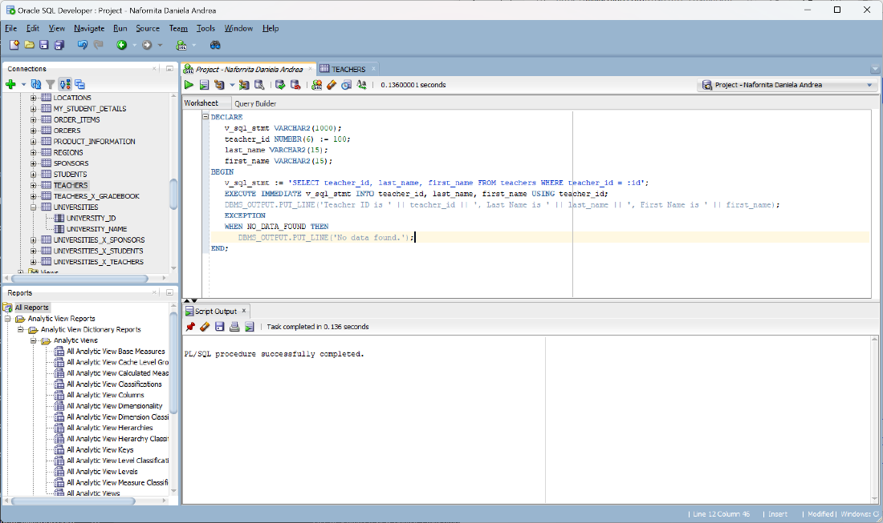

*1.2.2 LMD (Data Manipulation Language) commands: UPDATE statement using EXECUTE command:*

DECLARE

v_table_name VARCHAR2(30) := 'teachers';

BEGIN

EXECUTE IMMEDIATE 'UPDATE ' || v_table_name || ' SET FIRST_NAME = ''Jane Smith'' WHERE TEACHER_ID = 1';

DBMS_OUTPUT.PUT_LINE('Data updated in table ' || v_table_name || '.');

END;

/

DECLARE

v_table_name VARCHAR2(30) := 'sponsors';

BEGIN

EXECUTE IMMEDIATE 'UPDATE ' || v_table_name || ' SET SPONSOR_NAME = ''Jane Smith'' WHERE SPONSOR_ID = 1';

DBMS_OUTPUT.PUT_LINE('Data updated in table ' || v_table_name || '.');

END;

/

DECLARE

v_table_name VARCHAR2(30) := 'Students';

BEGIN

EXECUTE IMMEDIATE 'UPDATE ' || v_table_name || ' SET FIRST_NAME = ''Nafornita Daniela'' WHERE STUDENT_ID = 8';

DBMS_OUTPUT.PUT_LINE('Data updated in table ' || v_table_name || '.');

END;

/

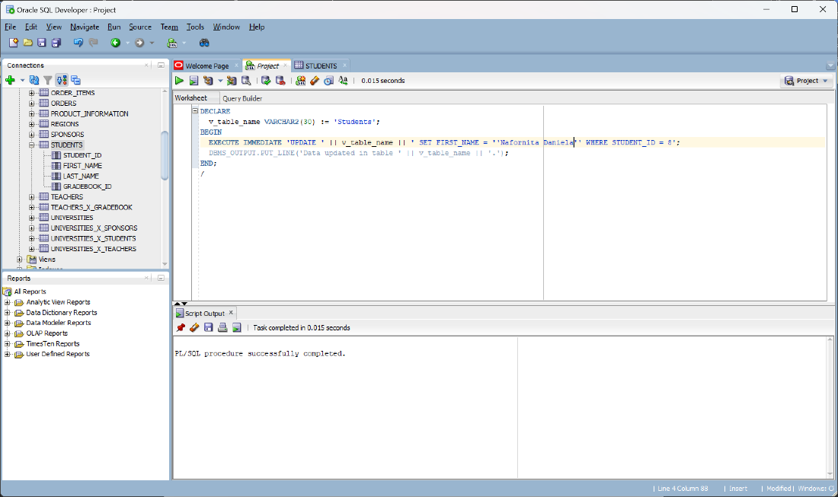

*1.2.2 LMD (Data Manipulation Language) commands: DELETE statement using EXECUTE command:*

DECLARE

v_table_name VARCHAR2(30) := 'SPONSORS';

BEGIN

EXECUTE IMMEDIATE 'DELETE FROM ' || v_table_name || ' WHERE SPONSOR_ID = 1';

DBMS_OUTPUT.PUT_LINE('Data deleted from table ' || v_table_name || '.');

END;

/

DECLARE

v_table_name VARCHAR2(30) := 'TEACHERS';

BEGIN

EXECUTE IMMEDIATE 'DELETE FROM ' || v_table_name || ' WHERE TEACHER_ID = 1';

DBMS_OUTPUT.PUT_LINE('Data deleted from table ' || v_table_name || '.');

END;

/

*1.3.1 Interaction with the Oracle server through SQL commands (LDD and LMD): the use of execute immediate, particularities regarding the use of the select command as well as row and group level functions.*

Using row-level functions in a SELECT query:

SELECT FIRST_NAME, LENGTH(FIRST_NAME) AS name_length FROM TEACHERS;

Using group-level functions in a SELECT query:

SELECT TEACHER_ID, AVG(SALARY) AS avg_salary FROM TEACHERS GROUP BY TEACHER_ID;

***2. Alternate and repetitive structures.***

*IF-THEN-ELSE statement:*

DECLARE

SALARY NUMBER;

BEGIN

SELECT SALARY INTO SALARY FROM teachers WHERE teacher_id = 5;

IF SALARY >= 2000 THEN

DBMS_OUTPUT.PUT_LINE('Teacher has not minimum per economy.');

ELSE

DBMS_OUTPUT.PUT_LINE('Teacher has minimum per economy.');

END IF;

END;

/

*“CASE” statement:*

DECLARE

v_university_id NUMBER := 1;

v_university_name VARCHAR2(100);

BEGIN

SELECT university_name INTO v_university_name FROM universities WHERE university_id = v_university_id;

CASE v_university_name

WHEN 'UAIUM' THEN

DBMS_OUTPUT.PUT_LINE('Universitatea Ion Mincu.');

WHEN 'ASE' THEN

DBMS_OUTPUT.PUT_LINE('It is Academia de Studii Economice.');

WHEN 'UTM' THEN

DBMS_OUTPUT.PUT_LINE('It is Universitatea Titu Maiorescu.');

WHEN 'UMFCD' THEN

DBMS_OUTPUT.PUT_LINE('It is Universitatea de medicina si farmaice Carol Davilla.');

WHEN 'UniBuc' THEN

DBMS_OUTPUT.PUT_LINE('It is Universitatea Bucuresti.');

WHEN 'UNATC' THEN

DBMS_OUTPUT.PUT_LINE('It is Universitatea de Actorie.');

ELSE

DBMS_OUTPUT.PUT_LINE('Invalid University.');

END CASE;

END;

/

*FOR LOOP statement:*

DECLARE

v_sum NUMBER := 0;

BEGIN

FOR i IN 2..10 LOOP

SELECT sponsor_id INTO v_sum FROM sponsors WHERE sponsor_id = i;

v_sum := v_sum + i;

END LOOP;

DBMS_OUTPUT.PUT_LINE('Sum of sponsor IDs from 1 to 10: ' || v_sum);

END;

/

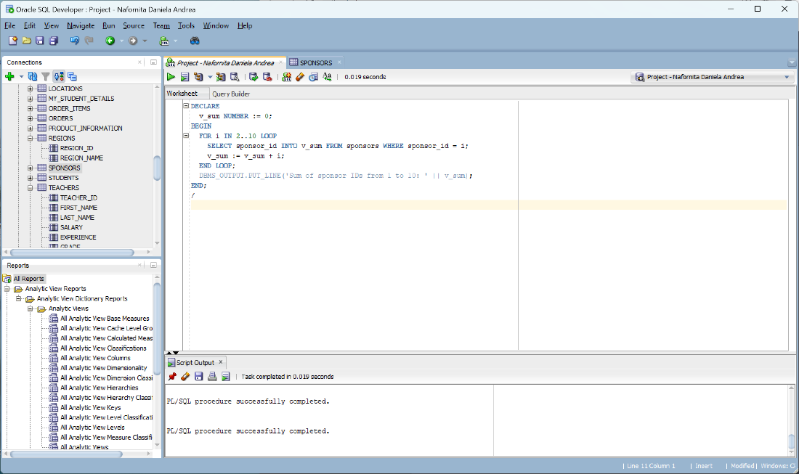

*WHILE LOOP statement:*

DECLARE

v_count NUMBER := 1;

v_student_id NUMBER;

v_first_name VARCHAR2(100);

v_last_name VARCHAR2(100);

BEGIN

WHILE v_count <= 5 LOOP

SELECT student_id, first_name, last_name INTO v_student_id, v_first_name, v_last_name

FROM students WHERE student_id = v_count;

DBMS_OUTPUT.PUT_LINE('Student ID: ' || v_student_id);

DBMS_OUTPUT.PUT_LINE('Name: ' || v_first_name || ' ' || v_last_name);

v_count := v_count + 1;

END LOOP;

END;

/

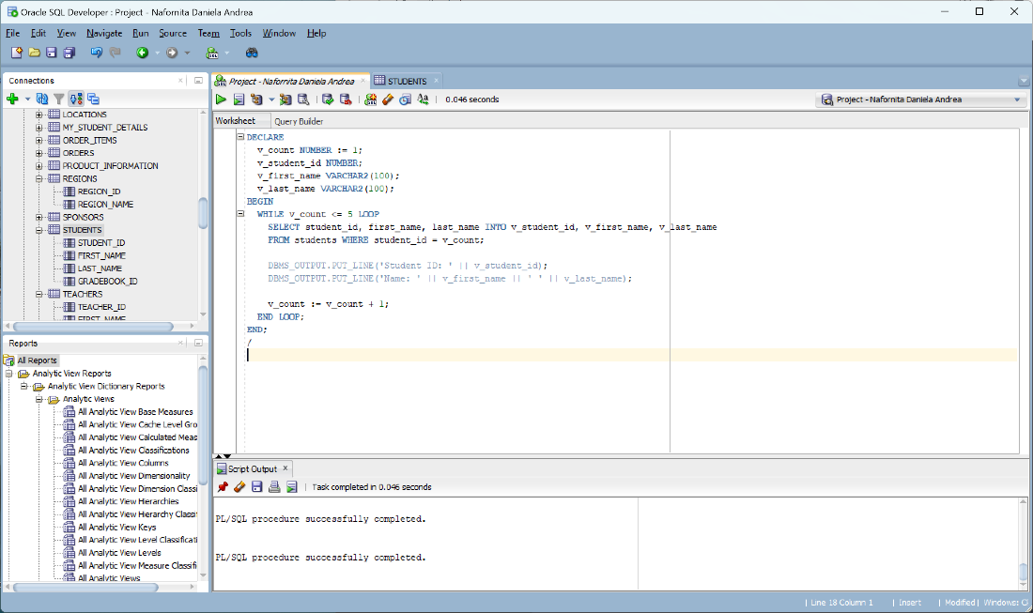

*EXCEPTION statement:*

DECLARE

v_num1 NUMBER;

v_num2 NUMBER;

v_result NUMBER;

BEGIN

SELECT no_of_presences, no_of_restances

INTO v_num1, v_num2

FROM gradebook

WHERE gradebook_id = 5;

BEGIN

v_result := v_num1 / v_num2;

EXCEPTION

WHEN ZERO_DIVIDE THEN

DBMS_OUTPUT.PUT_LINE('Error: Division by zero.');

END;

END;

/

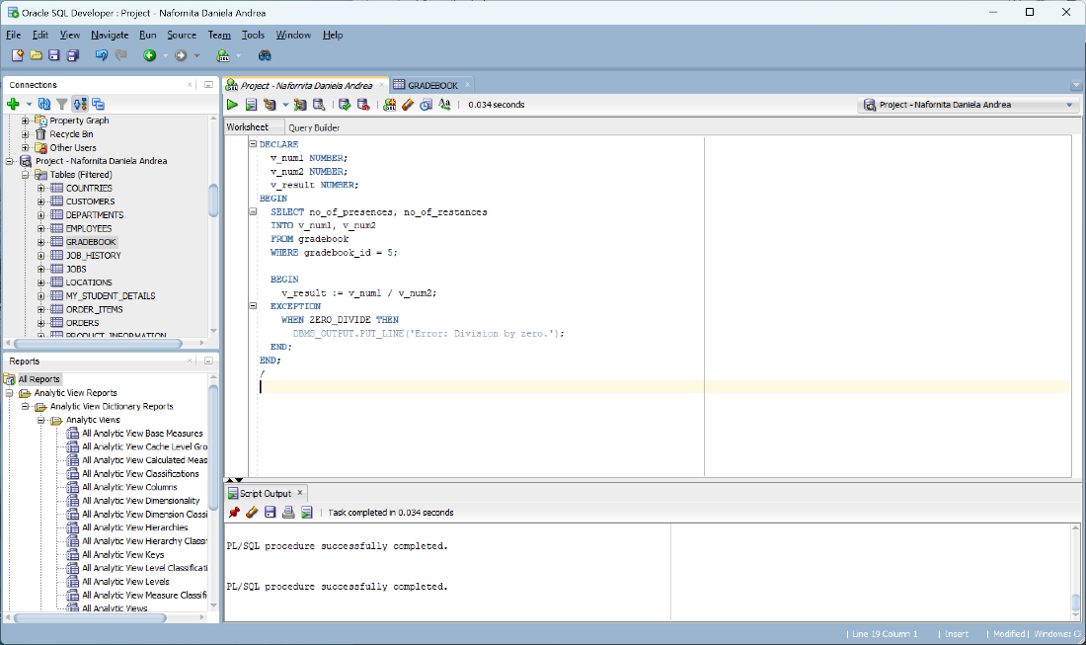

*Nested Blocks:*

DECLARE

v_num1 NUMBER := 10;

v_num2 NUMBER := 5;

BEGIN

DECLARE

v_result NUMBER;

v_teacher_id NUMBER := 5; -- Specify the teacher ID you want to retrieve data for

BEGIN

SELECT salary, teacher_id -- Replace column1 and column2 with the actual column names from the teachers table

INTO v_num1, v_num2

FROM teachers

WHERE teacher_id = v_teacher_id;

v_result := v_num1 + v_num2;

DBMS_OUTPUT.PUT_LINE('Result: ' || v_result);

END;

END;

/

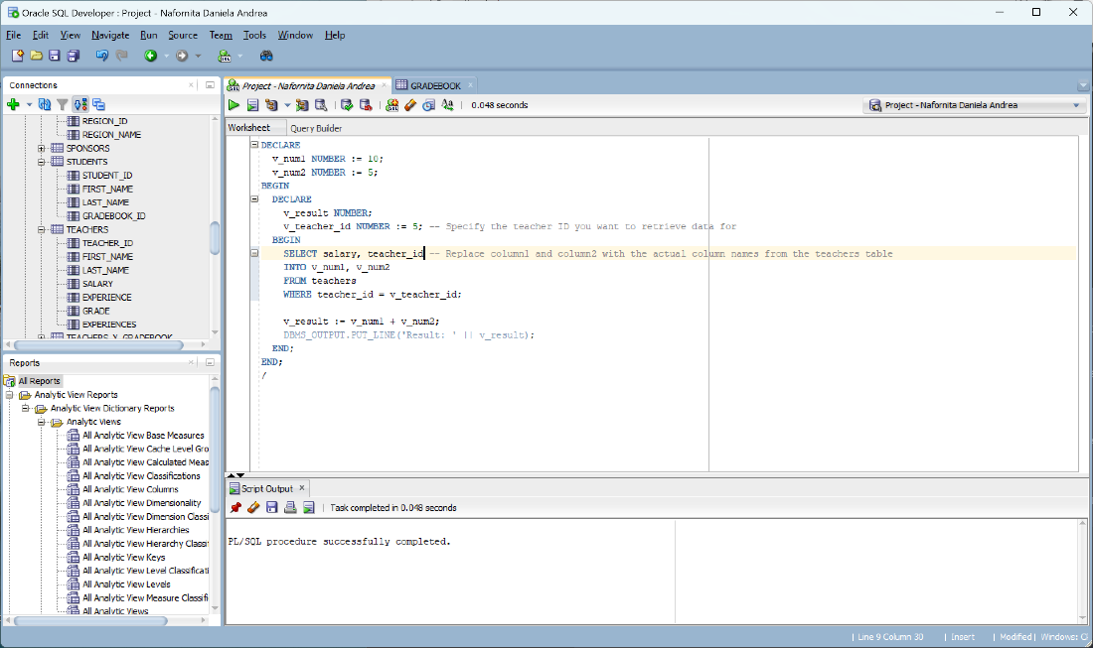

*GO TO statement:*

DECLARE

v_count NUMBER := 1;

BEGIN

<<my_label>>

LOOP

DBMS_OUTPUT.PUT_LINE('Count: ' || v_count);

v_count := v_count + 1;

IF v_count > 5 THEN

EXIT my_label;

END IF;

END LOOP my_label;

END;

/

*EXIT statement:*

DECLARE

v_sum NUMBER := 0;

BEGIN

FOR i IN 1..10 LOOP

v_sum := v_sum + i;

IF v_sum > 20 THEN

EXIT;

END IF;

END LOOP;

DBMS_OUTPUT.PUT_LINE('Sum: ' || v_sum);

END;

/

*CONTINUE statement:*

DECLARE

v_sum NUMBER := 0;

BEGIN

FOR i IN 1..10 LOOP

IF i = 5 THEN

CONTINUE;

END IF;

v_sum := v_sum + i;

END LOOP;

DBMS_OUTPUT.PUT_LINE('Sum: ' || v_sum);

END;

/

*CONTINUE statement:*

DECLARE

CURSOR c_employees IS

SELECT * FROM employees;

BEGIN

FOR emp IN c_employees LOOP

DBMS_OUTPUT.PUT_LINE('Employee Name: ' || emp.name);

END LOOP;

END;

/

***3. Data collections (index by table, nested table, varray)***

*3.1 Index by table (Associative Array) based on the "teachers" table:*

DECLARE

TYPE teacher_info IS TABLE OF teachers%ROWTYPE INDEX BY PLS_INTEGER;

v_teacher_info teacher_info;

BEGIN

-- Populating the index by table

FOR rec IN (SELECT * FROM teachers) LOOP

v_teacher_info(rec.teacher_id) := rec;

END LOOP;

-- Accessing teacher information by teacher ID

DBMS_OUTPUT.PUT_LINE('Teacher ID: ' || v_teacher_info(1).teacher_id);

DBMS_OUTPUT.PUT_LINE('Teacher Name: ' || v_teacher_info(1).FIRST_NAME);

DBMS_OUTPUT.PUT_LINE('Teacher last name: ' || v_teacher_info(1).LAST_NAME);

END;

/

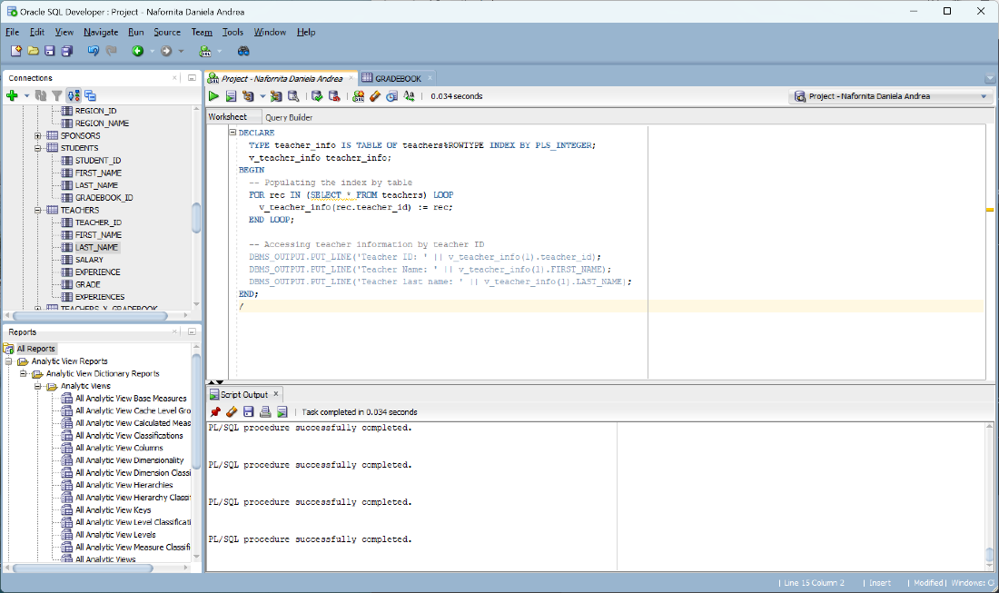

*3.2 Nested table based on the "Universities" table:*

DECLARE

TYPE university_list IS TABLE OF universities%ROWTYPE;

v_university_list university_list := university_list();

-- Populating the nested table

CURSOR c_universities IS

SELECT * FROM universities;

BEGIN

FOR rec IN c_universities LOOP

v_university_list.EXTEND;

v_university_list(v_university_list.LAST) := rec;

END LOOP;

-- Looping through the nested table

FOR i IN v_university_list.FIRST..v_university_list.LAST LOOP

DBMS_OUTPUT.PUT_LINE('University ID: ' || v_university_list(i).university_id);

DBMS_OUTPUT.PUT_LINE('University Name: ' || v_university_list(i).university_name);

END LOOP;

END;

/

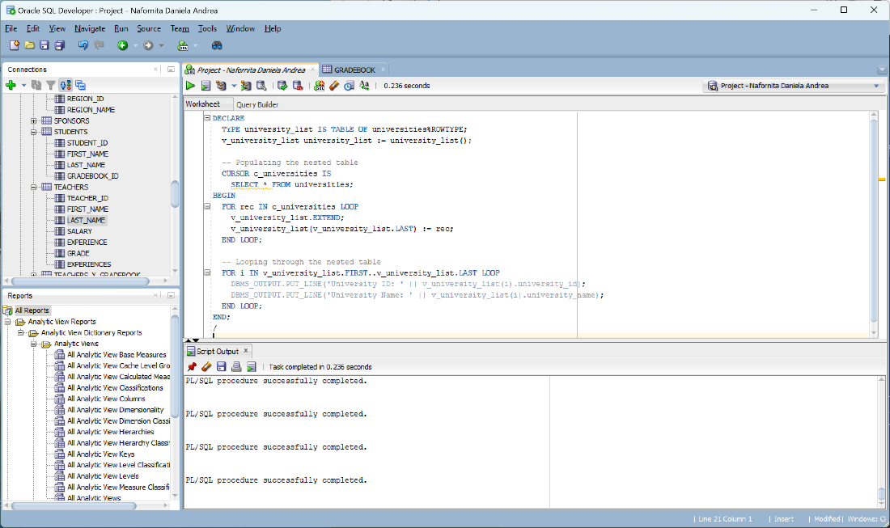

*3.3 Varray (Variable-size Array) based on the "students" table:*

SET SERVEROUTPUT ON

DECLARE

TYPE student_names IS VARRAY(10) OF students.first_name%TYPE;

v_student_names student_names := student_names();

-- Populating the varray

CURSOR c_students IS

SELECT first_name FROM students;

BEGIN

FOR rec IN c_students LOOP

v_student_names.EXTEND;

v_student_names(v_student_names.COUNT) := rec.first_name;

END LOOP;

-- Looping through the varray

FOR i IN 1..v_student_names.COUNT LOOP

DBMS_OUTPUT.PUT_LINE('Student Name: ' || v_student_names(i));

END LOOP;

END;

/

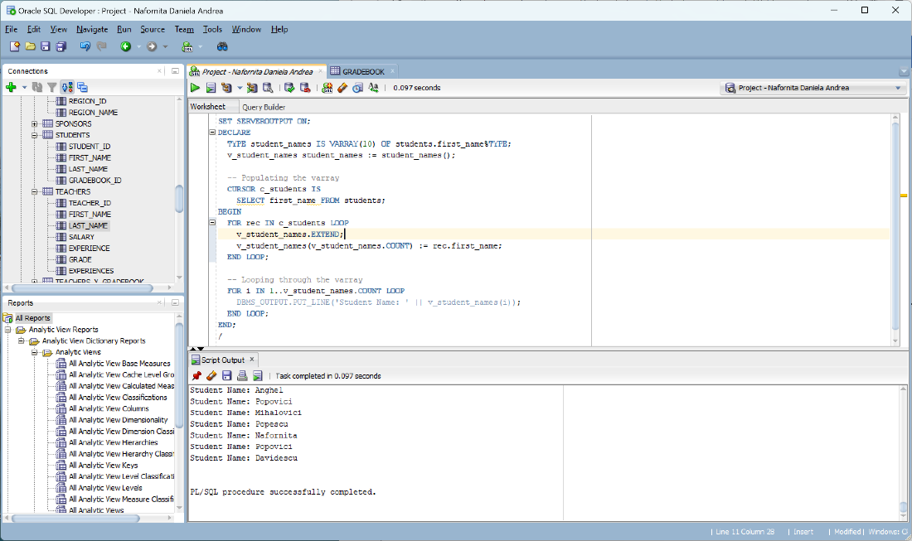

***4. Handling exceptions. (at least 3 implicit, 2 explicit)***

*4.1.1 Implicit exceptions - NO_DATA_FOUND Exception:*

BEGIN

DELETE FROM students

WHERE student_id = 100; -- assuming no such student exists

EXCEPTION

WHEN NO_DATA_FOUND THEN

DBMS_OUTPUT.PUT_LINE('No student found with ID 100.');

END;

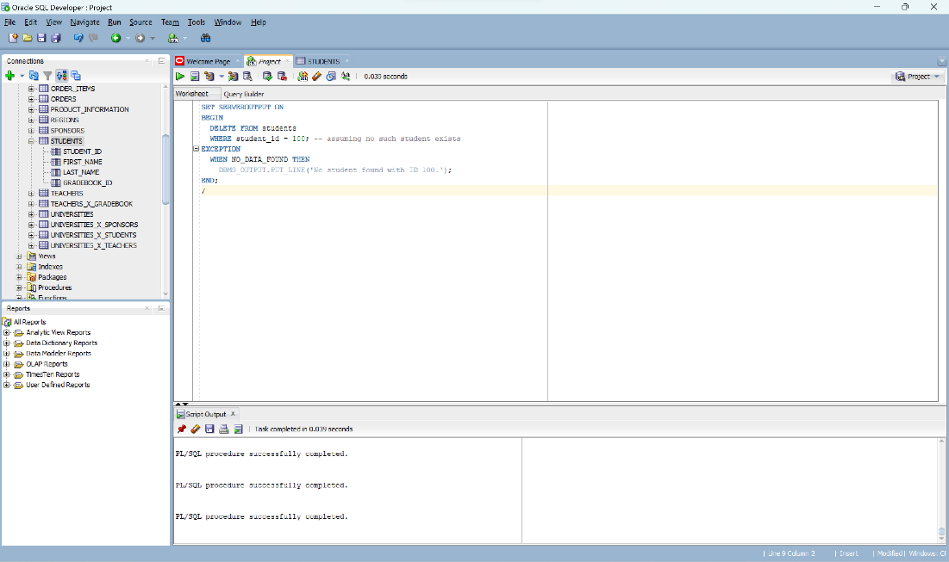

*4.1.2 Implicit exceptions - ZERO_DIVIDE Exception:*

Assume we have a procedure to calculate the average salary of teachers and we're dividing the total salary by the number of teachers. If there are no teachers, this would cause a divide by zero error.

DECLARE

total_salary NUMBER(8,2);

num_teachers NUMBER(6);

avg_salary NUMBER(8,2);

BEGIN

SELECT COUNT(*) INTO num_teachers FROM teachers;

SELECT SUM(salary) INTO total_salary FROM teachers;

avg_salary := total_salary / num_teachers;

DBMS_OUTPUT.PUT_LINE('Average Salary: ' || avg_salary);

EXCEPTION

WHEN ZERO_DIVIDE THEN

DBMS_OUTPUT.PUT_LINE('Cannot divide by zero. No teachers found.');

END;

*4.1.3 Implicit exceptions - VALUE_ERROR Exception:*

Assume we're creating a procedure to update the teacher's salary. If the salary value exceeds the maximum value allowed by the **salary** field in the **teachers** table, it would cause a **VALUE_ERROR**.

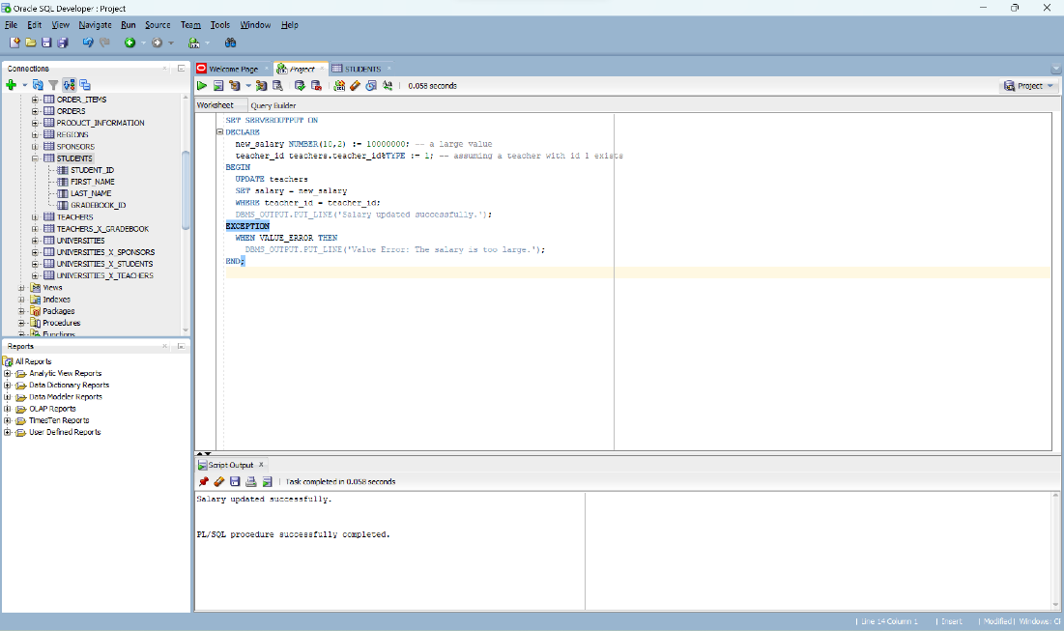

*4.2.1 Explicit exceptions -* Explicitly raising an exception:

we are checking if the **salary** of a teacher exceeds a certain limit, and if it does, we raise an exception.

DECLARE

max_salary_allowed NUMBER(8,2) := 10000;

high_salary EXCEPTION;

teacher_salary teachers.salary%TYPE;

teacher_id teachers.teacher_id%TYPE := 1; -- assuming a teacher with id 1 exists

BEGIN

SELECT MAX(salary) INTO teacher_salary FROM teachers WHERE teacher_id = teacher_id;

IF teacher_salary > max_salary_allowed THEN

RAISE high_salary;

END IF;

DBMS_OUTPUT.PUT_LINE('Teacher salary is within the allowed limit.');

EXCEPTION

WHEN high_salary THEN

DBMS_OUTPUT.PUT_LINE('The salary of the teacher exceeds the maximum allowed limit.');

WHEN TOO_MANY_ROWS THEN

DBMS_OUTPUT.PUT_LINE('More than one teacher found with the same ID.');

END;

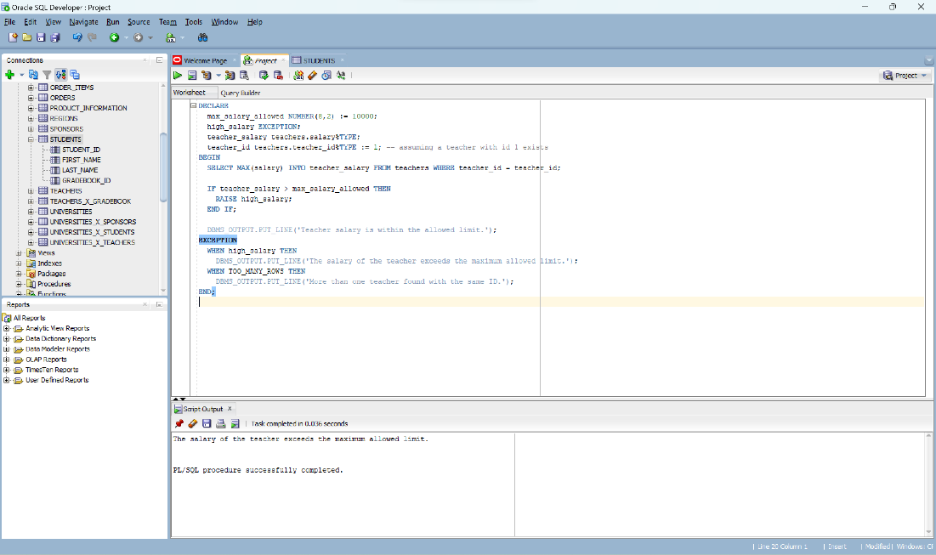

*4.2.2 Explicit exceptions - Raising a predefined exception explicitly:*

For instance, let's say we want to create a procedure to increase the salary of a teacher, but we want to put a cap on the maximum allowable salary. If the new salary exceeds this cap, we want to raise the **VALUE_ERROR** exception.

DECLARE

max_salary_allowed NUMBER(8,2) := 10000;

teacher_salary teachers.salary%TYPE;

teacher_id teachers.teacher_id%TYPE := 1; -- assuming a teacher with id 1 exists

BEGIN

SELECT MAX(salary) INTO teacher_salary FROM teachers WHERE teacher_id = teacher_id;

teacher_salary := teacher_salary * 1.1; -- giving a 10% raise

IF teacher_salary > max_salary_allowed THEN

RAISE VALUE_ERROR;

ELSE

UPDATE teachers SET salary = teacher_salary WHERE teacher_id = teacher_id;

DBMS_OUTPUT.PUT_LINE('Salary updated successfully.');

END IF;

EXCEPTION

WHEN VALUE_ERROR THEN

DBMS_OUTPUT.PUT_LINE('The new salary exceeds the maximum allowed limit.');

WHEN TOO_MANY_ROWS THEN

DBMS_OUTPUT.PUT_LINE('More than one teacher found with the same ID.');

END;

***5.* Managing cursors: implicit and explicit (with and without parameters)**

**Implicit Cursors**:

They are created automatically when an SQL statement is executed. Here is an example of an implicit cursor using your provided tables. The following block of code retrieves the maximum salary of a teacher and prints it:

DECLARE

max_salary NUMBER; -- Modify the datatype to NUMBER

BEGIN

SELECT MAX(salary) INTO max_salary FROM teachers;

DBMS_OUTPUT.PUT_LINE('Maximum salary is: ' || max_salary);

END;

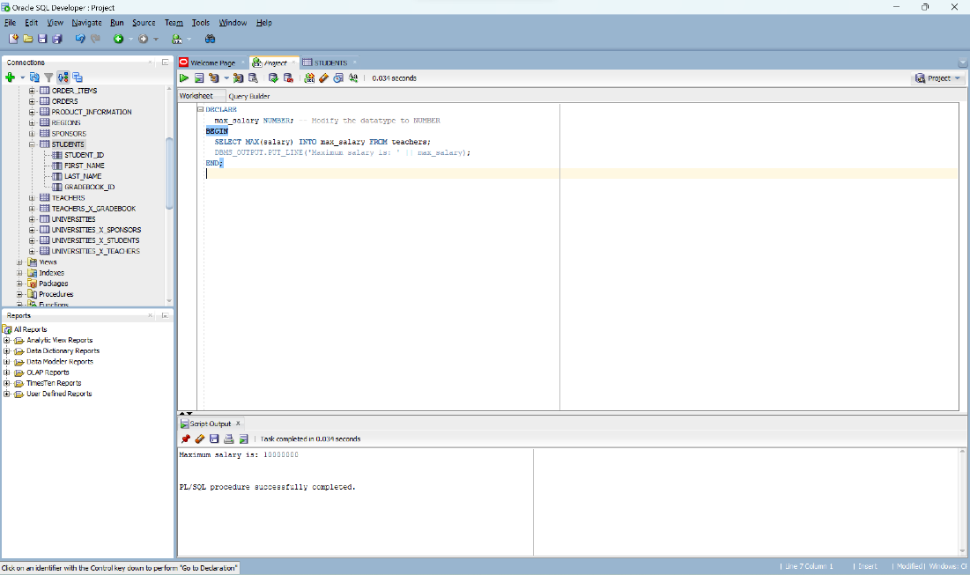

**Explicit Cursors**:

Explicit cursors are created by the programmers to handle queries that return more than one row. They give more control over the context area than implicit cursors.

E*xample without parameters:*

DECLARE

CURSOR teacher_cursor IS

SELECT teacher_id, first_name, last_name, salary

FROM teachers;

teacher_rec teacher_cursor%ROWTYPE;

BEGIN

OPEN teacher_cursor;

LOOP

FETCH teacher_cursor INTO teacher_rec;

EXIT WHEN teacher_cursor%NOTFOUND;

DBMS_OUTPUT.PUT_LINE('Teacher ID: ' || teacher_rec.teacher_id || ', Name: ' || teacher_rec.first_name || ' ' || teacher_rec.last_name || ', Salary: ' || teacher_rec.salary);

END LOOP;

CLOSE teacher_cursor;

END;

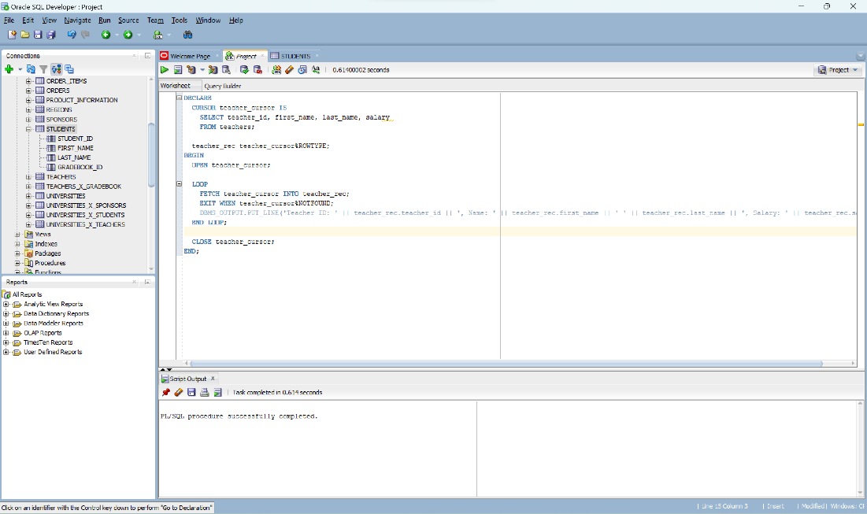

*Example with parameters:*

DECLARE

CURSOR teacher_cursor (p_teacher_id teachers.teacher_id%TYPE) IS

SELECT teacher_id, first_name, last_name, salary

FROM teachers

WHERE teacher_id = p_teacher_id;

teacher_rec teacher_cursor%ROWTYPE;

BEGIN

OPEN teacher_cursor(1); -- let's assume we're fetching the teacher with id 1

FETCH teacher_cursor INTO teacher_rec;

IF teacher_cursor%FOUND THEN

DBMS_OUTPUT.PUT_LINE('Teacher ID: ' || teacher_rec.teacher_id || ', Name: ' || teacher_rec.first_name || ' ' || teacher_rec.last_name || ', Salary: ' || teacher_rec.salary);

ELSE

DBMS_OUTPUT.PUT_LINE('No teacher found with the provided ID.');

END IF;

CLOSE teacher_cursor;

END;

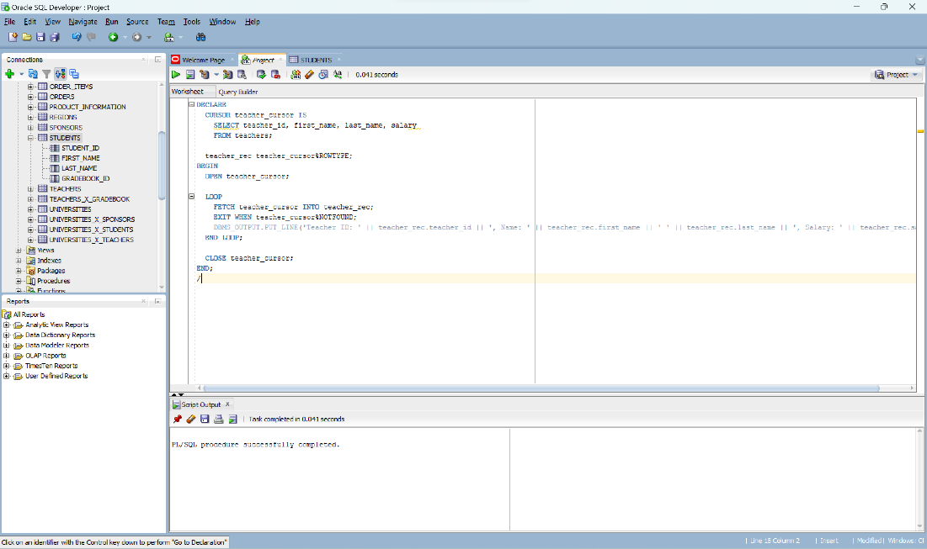

***6.* Functions, procedures, including these in packages. (at least 3 functions, 3 procedures, and a package that includes other functions and procedures)**

**1. Function to get Total Number of Sponsors**

CREATE OR REPLACE FUNCTION get_total_sponsors

RETURN INT

AS

total_sponsors INT;

BEGIN

SELECT COUNT(*) INTO total_sponsors FROM SPONSORS;

RETURN total_sponsors;

END;

/

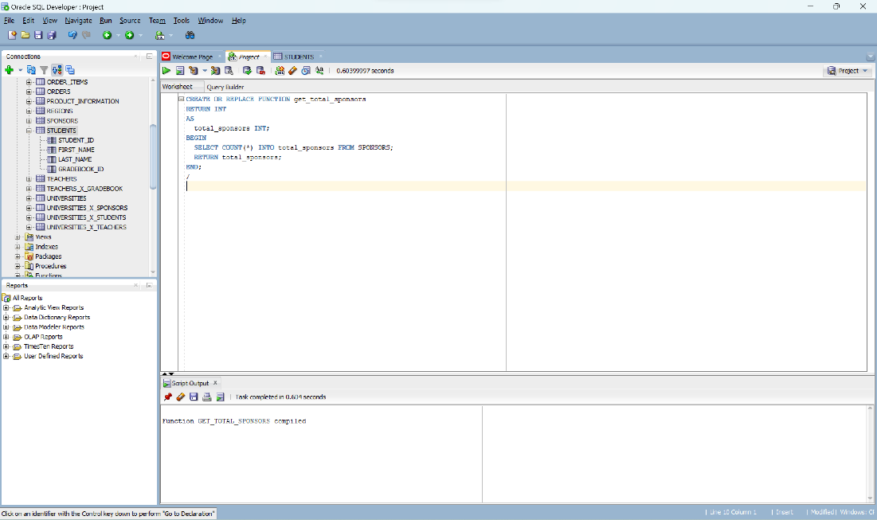

**2. Procedure to display and Calculate Average Salary of Teachers**

CREATE OR REPLACE FUNCTION calculate_average_salary

RETURN DECIMAL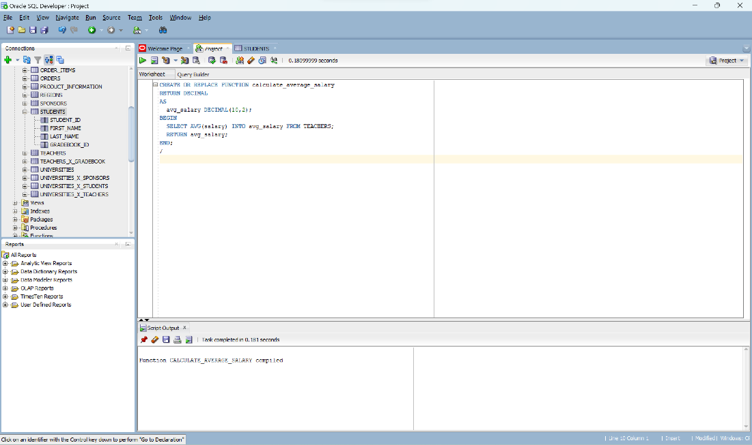

AS

avg_salary DECIMAL(10,2);

BEGIN

SELECT AVG(salary) INTO avg_salary FROM TEACHERS;

RETURN avg_salary;

END;

/

**3. This function retrieves the name of a university based on the given university ID**

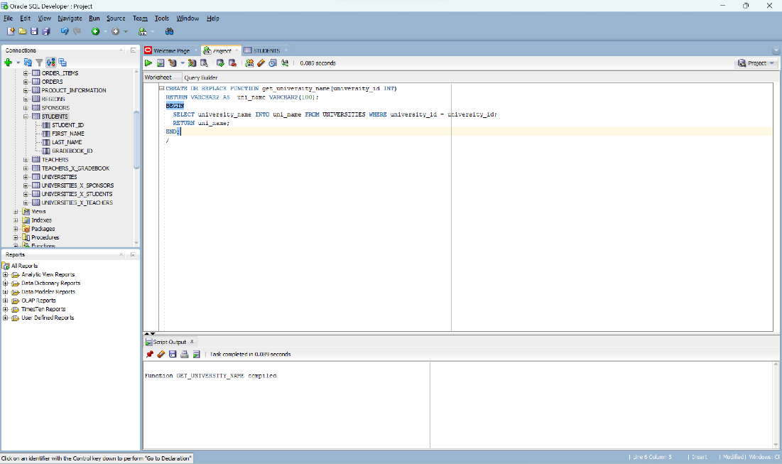

CREATE OR REPLACE FUNCTION get_university_name(university_id INT)

RETURN VARCHAR2 AS uni_name VARCHAR2(100);

BEGIN

SELECT university_name INTO uni_name FROM UNIVERSITIES WHERE university_id = university_id;

RETURN uni_name;

END;

/

**4. This procedure adds a new sponsor to the database.**

CREATE OR REPLACE PROCEDURE add_new_sponsor(

p_sponsor_id INT,

p_sponsorship_type VARCHAR,

p_sponsor_name VARCHAR

)

AS

BEGIN

INSERT INTO SPONSORS (sponsor_id, sponsorship_type, sponsor_name)

VALUES (p_sponsor_id, p_sponsorship_type, p_sponsor_name);

COMMIT;

END;

/

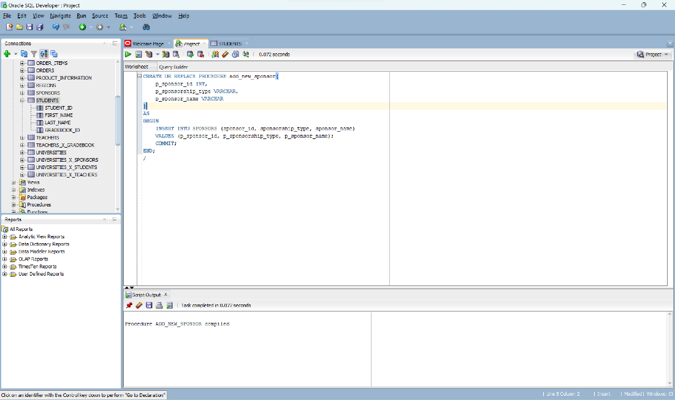

**5. This procedure updates the salary of a specific teacher.**

CREATE OR REPLACE PROCEDURE update_teacher_salary(

p_teacher_id INT,

p_new_salary DECIMAL

)

AS

BEGIN

UPDATE TEACHERS

SET salary = p_new_salary

WHERE teacher_id = p_teacher_id;

COMMIT;

END;

/

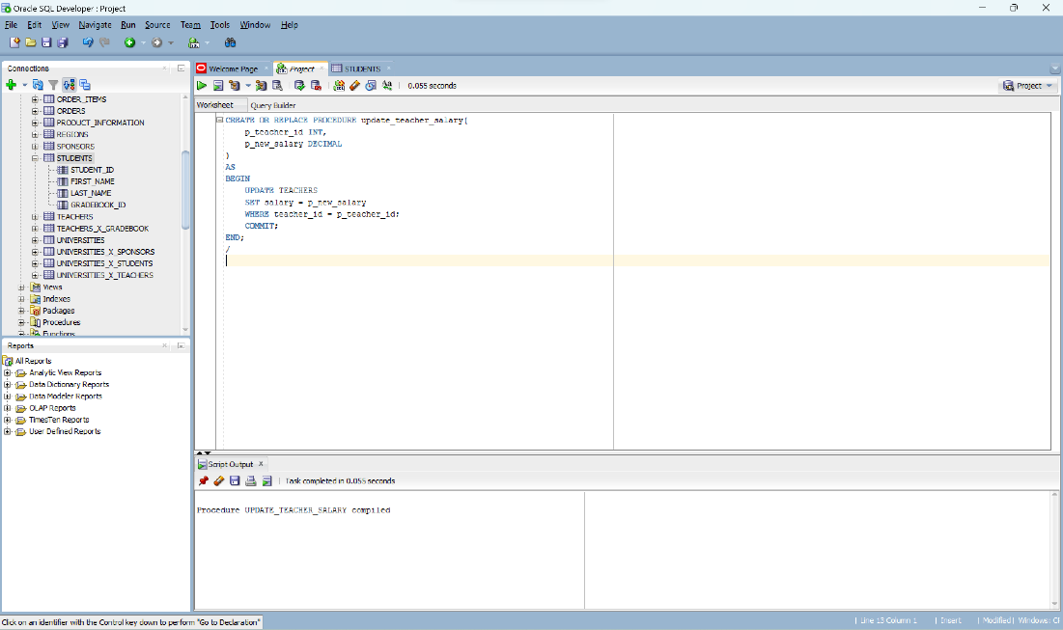

**6. This procedure deletes a student and the associated gradebook from the database.**

CREATE OR REPLACE PROCEDURE delete_student(p_student_id INT)

AS

BEGIN

DELETE FROM STUDENTS WHERE student_id = p_student_id;

DELETE FROM GRADEBOOK WHERE gradebook_id = p_student_id;

COMMIT;

END;

/

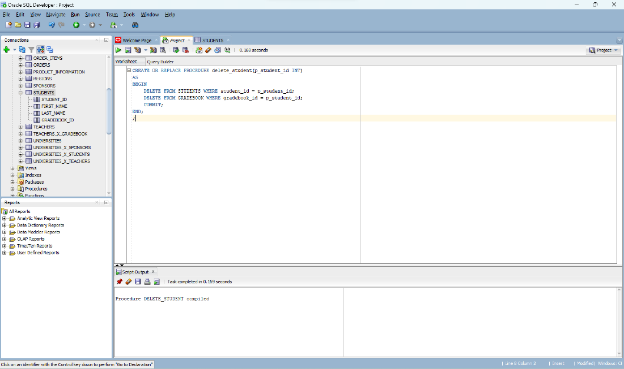

**7. This package includes functions and procedures related to universities.**

CREATE PACKAGE University1_Package AS

FUNCTION get_total_universities RETURN INT;

PROCEDURE add_new_university(

p_university_id INT,

p_university_name VARCHAR

);

PROCEDURE update_university_name(

p_university_id INT,

p_new_name VARCHAR

);

END University1_Package;

***6. statement-level and row-level triggers***

1. *Statement-Level Trigger:*

CREATE OR REPLACE TRIGGER trg_statement_level

AFTER INSERT OR UPDATE OR DELETE ON SPONSORS

DECLARE

total_sponsors INT;

BEGIN

SELECT COUNT(*) INTO total_sponsors FROM SPONSORS;

DBMS_OUTPUT.PUT_LINE('Total sponsors: ' || total_sponsors);

END;

/

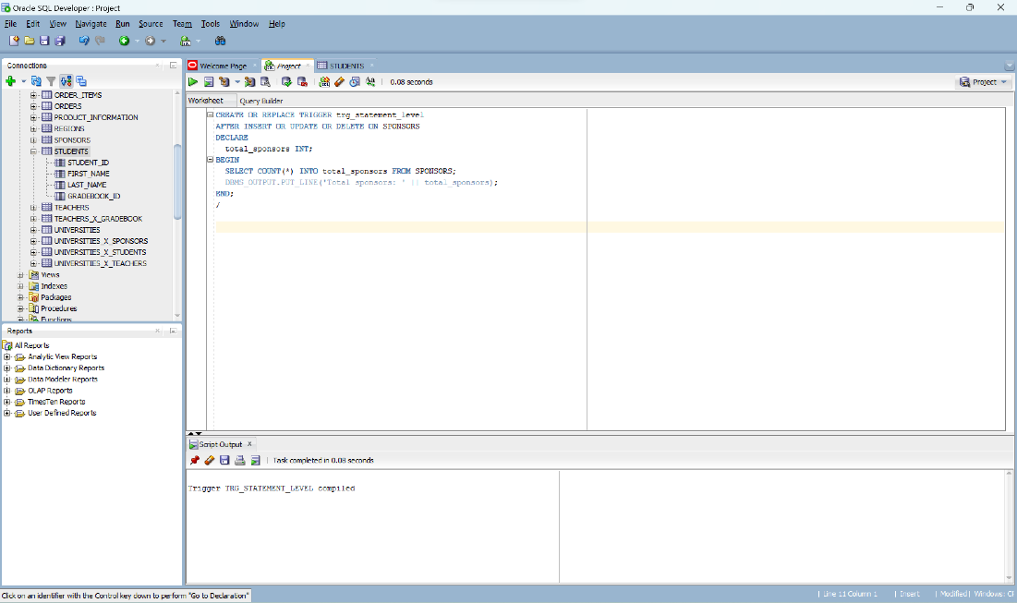

1. *Row-Level Trigger:*

CREATE OR REPLACE TRIGGER trg_row_level

AFTER INSERT OR UPDATE OF no_of_presences ON GRADEBOOK

FOR EACH ROW

BEGIN

IF :NEW.no_of_presences < 10 THEN

DBMS_OUTPUT.PUT_LINE('Low attendance! Student: ' || :NEW.gradebook_id);

END IF;

END;

/

